“Acting as a way of thinking”

Paper read at the conference “Performativity – A Paradigm for Studies of Art and Culture?” 29 November-3 December 2004, at the University of Copenhagen

PhD student Anders Lisdorf

Performance is a central factor in religions around the world, especially religious ritual. This has been duly noted in anthropological treatments. The basic question which has baffled anthropologists, is why perform at all? Why not just say it? The traditional textual paradigm has answered it with a focus on the meaning or “utterances” produced in ritual, thus reducing ritual to just another “code” among others that express a symbolic meaning derived from the cultural system. This does not explain why it should be performed, since it is just another way of speaking. The performative paradigm has focused on the fact that performance stimulated the senses, and therefore could achieve something which the linguistic could not [emotional stimulation thesis stated clearly?]. This effect could be societal change (Turner and Schechner), giving legitimacy to decisions or social structure, or producing social cohesion (effervescence, Durkheim, Rappaport).
I agree that emotional stimlation is indeed a central, maybe even the most central, explanation of why rituals are performed as opposed to spoken or read. What we could call the emotional stimulation thesis is from the outset a much more likely theory. But there are some loose ends, which are not explained by the emotional stimulation thesis: Some rituals are read such as prayers, incantations and spells, and 90 percent (my totally subjective estimate) of all ritual actions on a worldwide basis are extremely dull and repetitive. This obviously leaves an explanatory gap.
I would like to suggest that part of the explanatory gap of why rituals are performed as opposed to read or spoken, can be filled by realising that ritual performance also achieves cognitive effects, that could not have been achieved through mere talking. This will be done by considering the case of the most obviously information-procesing type of ritual : divinatory ritual, whose main function is to produce knowledge of what is hidden. By integrating the new insights it can hopefully shed new light on the performative processes involved in religious ritual. (The point of departure is recent works on the embodied mind and externalisation of cognition, which has surfaced in the cognitive sciences and philosophy of mind.) But how might performance be considered a way of thinking?

The case of divination
Divinatory rituals are especially suited because they are most obviously action, but they are also obviously producing information. One part of previous research has focussedon he logic are lack of logic inherent in divination systems. This has been largely an intelectuallistic effort. (REV???)
According to Evans-Pritchard the performance makes it more interesting why it is considered true. This implies that performance and dramatisation in general should make what is performed more credible. This is actually quite counterintuitive. Normally performance has just the opposite effect, it signifies distance, fiction, not-truth. It is left unexplained why performance n exactly this case should function diametrically opposite of how it usually functions. Thus the explanation cannot be said to be sufficiently elaborated.
Victor Turner has worked a lot with the performative aspects of rituals. I will here only mention hi view on divinatory ritual. Performance creates a “(..)communitas reality from which all social structures may be endlesly generated”(revelation – 23). In divination hidden conflicts are brought out and it can function as a mechanism of social redress because of performance. The problem is that it creates as many social problems as it solves, and the effects are not always useful (Mendonsa 1982), and it does not always have a clear element of social redress (as for example modern astrology). This explanation is therefore not sufficient either.
Let us consider one divination system in detail to see how performance might be alternatively conceptualised.

Externalised cognition

Let us start with ow one might think about thinking (Already Gilbert Ryle (The Concept of Mind, 1949) claimed that thinking could happen out in the public. This thought was untimely and not seriously considdered until recently.). I will work from the perspective of the cognitive sciences. Here the focus has been on internal information processing. The paradigmatic case is provided by David Marr’s work on vision (REF.1982). Marr distinguished three levels of description necessary for understanding any information-processing system: The first specifies what the system does, and why it does it. The second describes the “choice of representation of input and output and the algorithm to be used to transform one into the other” (Cited from Hutchins 1995, 50). The third level concerns “the details of how the algorithm and representation are realized physically”(Cited from Huchins 1995, 50). Whereas Marr intended this to be a description of what took place inside the brain of humans, the cognitive anthropologist, Edwin Hutchins, has forcefully argued that such a limitation by the skull is arbitrary and not necessary (1995). Hutchins has worked on navigation. He demonstrates that the computation takes place just as much internally as externally in navigation. He proposes to recast the understanding of computation that embrases this, why computation is defined as “(..)the propagation of representational state across a series of representational media”(Hutchins 1995, 117). These might be external or internal. Representational state is defined thus:
“I will refer to a configuration of the elements of a medium that can be interpreted as a representation of something else as a representational state of the medium. Representational states are propagated from one medium to another by bringing the states of the media into coordination with one another”(Hutchins 1995, 117).
The advantage of this approach is that there is no principal difference between the needle on the compass pointing north and the neuronal firing pattern in area V2 in the visual cortex. The first is brought into coordination with the latter, which in turn activates other neuronal firing patterns, that for example bring the representational state of V2 into coordinationo with a representation of the environment in the hippocampus. Thus computation can be seen as a dynamic process transgressing the boundaries of the skin, inpulses of action, in which media are being brought into coordination.
This process goes back and forth between the external and the internal. An excelent example of this comes from Andy Clark. We might be able to perform simple multiplications such as 3 X 4, but this is not possible for more comlicated ones, such as 7222 X 9422 (due to restrictions of working memoy). Instead we grab pen and paper and start writing: (2 X 2 =)4, (2 X 2 =)4, (2 X 4 =)8, (2 X 9=)18: 18844, and so forthWhat happens is that we reduce a complex problem to a sequence of simpler ones, that are within our cognitive abilities (Clark 1998, 61). In this process we use an external medium, paper and pen to bring the simpler problems to bear on the more complex. What happens is that we proceed through a propagation of representational state where different media (pen and paper) are brought into coordination. The calculation on the paper makes use of a specific algorithm, for the gradual propagation of representational state.
Appliying the multiplication system to Marr’s levels of description we get :
- The system solves complicated multiplication tasks
- The brain’s input are numerical symbols, which are transformed to an output that takes the form of new numerical symbols on the paper and an algorithm that specifies the location of the output, ending with a final number at the bottom.
- The numerical symbols are written by hand with a pen on paper, this makes them visible to the eye, which percieves them and transform them through the visual cortex to representations that might be transformed to new numbers, that, through the motor planning in the premotor cortex, might be transformed to new marks on the sheet.

This is not an isolated example. Some have argued that, indeed, this is a defining characteristic of humans, which explains the evolution of the human mind and culture, because it makes external memory possible(Donald 1998). However the interesting part is not so much the memory, as the problem solving. If memory cannot be used to solve a problem it is not interesting.
The phenomenon has been called scafolding, because like a scafold it supports thought. I prefer another metaphor, that of climbing a tree to get a view of the forrest in order to find your way to the sea. Imagine you are walking thorugh a forrest close to the sea, and you want to catch fish. In order to solve the problem where is the sea, you take advantage of the environment ( a nearby tree). First you put one foot in one place and your hands another, thenwhile your hands are holding you move the feet up, and resting on your feet the hands, so that gradually you come upwards. This is a sequence of actions that ultimately results in your view of the forest, which makes it possible to solve the problem of where to go. Neither the internal cognitive properties, nor the external are sufficient for solving this problem, what is necessary is the process. Through an oscilation between the internal cognitive and external environmental realm the organism advances in the solution of problems, so as to better navigate the environment.

Ifa

The Ifa divination system is found among the Yoruba in Nigeria. Many varieties and similar systems are found among neighboring people(Peek ???). It is one of the best testified divination systems. It was not, however, until the work of William Bascom, that a reasonable and thorough understanding of the system was reached. (Bascom did field work in the main city Ife, and other places)
It is a complex system akin to I Ching, based on 16 basic and 256 derived figures. These are made by the pairing of the 16 basic figures (16x16 = 256). Each of these 256 figures have individual names, and they are all placed in a hierarchy. To each figure a number of verses are attached. These are remembered by the diviner, the Babalawo. He should be able to recite minimum three verses for each figure. The figure that gives the answer to the clients problem, is found through the performance of a ritual, to which we no turn.
.
Consulting Ifa/The ritual

Background
People come to consult Ifa typically because they are about to embark on a journey, engage in warfare, kidnapping (!!!), orcases of disease “(..) in short, wherever there is doubt of the future” (Bascom 1969, 118). You could say that the motivation is some sort of existential problem, therefore it is not surprising that that “the objective of Ifa divination is to determine the correct sacrifice necessary to secure a favourable resolution of the problem confronting the client”(60).

The participants, and objects.
Consultation of Ifa entails the participation of two persons the diviner, or Babalawo, and a client.

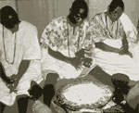
A Babalawo is seen in front of his divining tray.

The Babalawo is a specially trained ritual specialist. Estimates are that it takes on average 10 to 15 years(Akinasso ????). The client is whoever has a problem. There is often no relation between diviner and client, at least in the big cities.
A number of objects are necessary for the consultation. First of all the 16 palmnuts, which are the primary means of consultation. Also a divining chain (opele) is needed. This is a chain three or four
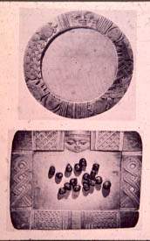

At the top a divining tray, at the bottom the 16 palmnuts used for divining.

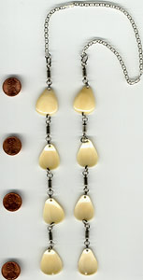
A diviningchain made from shells, which can be turned up or downwards.

foot long. Eight cowries, pods or shells are attached too the chain separated by an equal length [Photo]. These cowries can either be turned upside or downside. These two devices are the primary means of producing the signs needed in Ifa divination. Appart from this the diviner has a divining bag. In this bag are a number of code objects, such as “Cowries and other kinds of shells, vertebrae
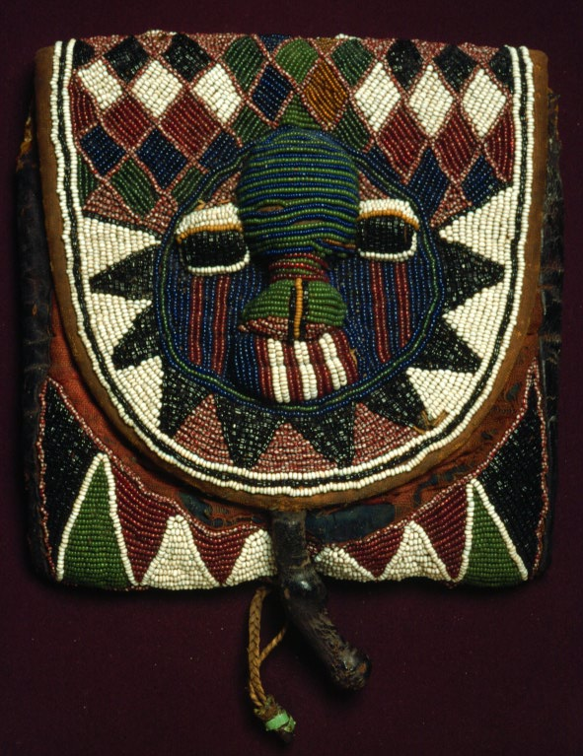
A divining bag, in which the objects needed for divination is contained.

and other small bones, horns and teeth, broken bits of china and glass, pebbles, and different kinds of seeds” (32). Apart from this also a divining tray and some powder in which to write is used to keep track of the casts.

The procedure
As mentioned at the beginning, the overall goal is to find a solution to the problem of what will happen in the future. This solution always involves some kind of sacrifice. The actual production of this is through the employment of the mentioned objects in ritual. To produce the Ifa figures, two primary methods are used. It is either by the use of palm nuts or the divining chain(REVISE).
The palm nuts are the most time demanding, but also considered the most reliable. All the nuts are put in the left hand and grabbedby the right, because of the size of the palmnuts either one or two palm nuts will remain. If one is left two marks are made in the powder on the diviningtray, if two one. The marks are made under each other in two rows of four [figure]. There are 256 possible figures each with its own unique name.

I II
II II
I II
I I
Example of Odu figure obtained through casting the palmnuts.

The divining chain also produces two rows of four binary figures. The diviner holds it at the midle and throws it to the ground, so that the cowries on the chain will face up or down, and they will form two rows. Thus the divining chain can also produce the same 256 figures as the palmnuts, but this method is faster.
These two techniques can be used in different ways
- Singlecast – employed to determine which figures verses should be recited
- Doublecast – employed to produce a yes or no answer. This is achieved through the client poing a question in the positive to one code object, to which the chain is cast, and then the same question in the negative to another code object. The cast producing the figure highest in the hierarchy is chosen.
- three to five casts – employed to determine which of a number of alternatives are correct. This is used for example in determining which of the five types of fortune/misfortune is refered to in the prediction. Each fortune/misfortune is represented by a code object: Good fortune: china:defeat enemy, bone:childre, snail:marriage, cowries:money, stone:long life. The bad fortunes are china:loss, cowries:want of money, stone:fight, snail:illness: Bone:death (Bascom 1967 54-58). By each codeobject the diviner will cast the chain. The figure with the highest ranking will be the one referred to. The same principle can be used in determining candidates for office. If there are for example three candidates, the candidate, to whom the cast with the highest ranking figure is cast, will be appointed.
Typically the palm nuts will be used for 1) and the divining chain for the rest, but in particularly important cases the palmnuts can also be used for 2) and 3).
The different techniques are employed at various points on the divination ritual. Let us consider the temporal organisation of the ritual:

The ritual

The ritual starts with an invocation of Ifa to attend.
- Singlecast using the palm nuts are used to determine the figure whose verses should be recited
- Doublecasts using the divining chain are used to determine prognostication good/evil [after this it is possible to go to 10]
- Five casts to find out which good/evil (code objects used depend on 2) [if good fortune it is possible to go to 10]
- A series of doublecasts are used to know more details of the good/evil
- A doublecast is made to determine if sacrifice should be ebo/adimu [if ebo go to 10]
- Five casts to determine to whom [if not white deities go to 8]
- Series of double cast to determine which deity
- Five casts to obtain knowledge of what is required as Adimu [if not living creature go to 10]
- Double cast to find out which animal
- Verses pertaining to the figure from 1 are selected and recited.
- Double cast to determine the correct sacrifice.

These distinct fases of the divination process can be juxtaposed to the actions of the different media. See below for a graphical representation

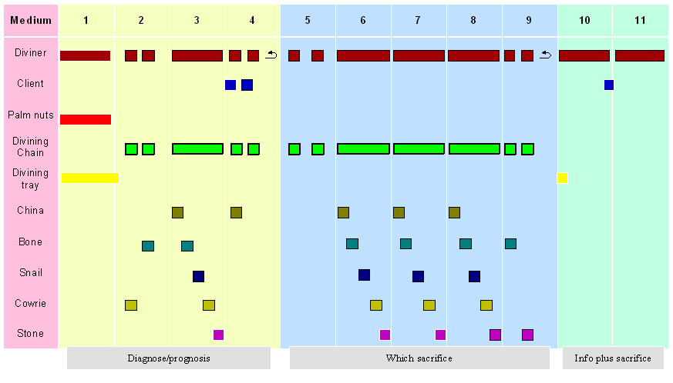
Figure The Ifa divination process

To produce the marks on the divining tray a technique involving the palmnuts is used. If the technique produces one not in the left hand this is the input for the production of two marks in the powder. When four marks have been made by repeating this four more marks are producedto the right of the column. After this is done, the marks in the powder are the input for an epistemic system matching the figure to a name in the diviners mind. This in turn is the input for a squence of verses in memory, which wil be recited. This recitation is input for the client who matches it to his situation, and produces information.
The divining chain is manipulated so as to fall giving two rows of cowries, which might face upwards or downwards. This is the input for an epistemic system matching the figure to a name in the diviners mind. This input is matched to a code object. The procedure is repeated x number of times, after which the different figures names are compared in the mind of the diviner, who has memorized their hierarchy. The figure who is highest in the hierarchy is singled out and the code object matched with it selected as the answer.
This is just the generic sense of how the algorithm is realized physically. It is more complicated since the sequence also determines what is represented. E.g. if in 3 the output is good, the piece of china will have a different representation (defeat enemy), than if the output In 3 was evil. Then the representation would have been loss.
Let us consider phase two, where it is determined whether the prognosis is good or bad. The diviner takes a piece of cowrie, touches it with the divining chain, and then casts it, sees it and matches it t its name, then he takes a piece of bone and touches it with the divining chain, which he again casts. He reads the formation and mathes it to its name. He then compares the rankings of the two, selects the higher and sees which object it is connected to. What happens is that different representational media are brought into coordination with one another. First the cowrie and the chain and through the subsequent physical manipulation of the chain, a representation is formed physically by the position of the shells. This is seen by the diviner, who matches it with his semantic knowledge to recognise the name of the physical formation. This is found and held in memory. The procedure is repeated with the bone to which a name for the odu is found. Know this is compared in the diviners mind with his knowledge of the ranking of the different odu. The highest ranking is found and the object to which it is attached is selected. To the object is attached a meaning: Cowrie shells used to be used as money amongth yoruba, thus ofcourse rendering a positive prognostication, bone naturally is known from dead creatures, thus rendering it a negative prognostication.
Notice how the representational media are both internal and external and that the oscilation between them are achieved through allingment into a temporal coordination (contiguity).

Interpretation

If we see the Ifa system as a computational system, we can describe it according to the points at the beginning. First it can be seen that in the divination process the representational state is propagated across different media, external and internal: from individual brains and bodies (the diviner and the client) to a number of physical objects (palm nuts, divining chain, code objects, divining tray and powder). According to Marr’s levels of description we can specify how the system works:

What the system does, and why it does it. The system produces information about the future and which sacrifice should be offered to whom. The reason for this is, that the consulting client is motivated by actual or potential misfortune.

Choice of representation of input and output and the algorithm to be used to transform one into the other: The basic representations are the 256 figures. Individual figures are matched to their individual names. Names are matched to verses, or organised relative to a hierarchy. Names of figures can be matched to different alternatives. Relative position on the hierarchy of a name thus matched to an alternative is determined to select one of the alternatives.

The details of how the algorithm and representation are realized physically: the divination ritual employs two different ways of physically representing the figures: the marks in the powder on the divining tray and the divining chain.
It can be seen that each step in the performance of the ritual brings the client closer to the information about the future and the sacrifice needed. Each step propagates representational state, across different representational media and each step is necessary to complete in order to proceed, i.e. it is not possible just to do number 11 to savetime and money. It would not work just as you cannot do complicated multiplication, by just doing the last of the series of multiplications.
What happens is an oscilation between the internal and the external through the performance of each step. It can be seen that this oscilation between the internal mental states of the participants, and external environmental state of the material is caried forward by performance. Thus performance may be viewed as the metabolism of thought involving externalised representational media.

Representation of what

The Ifa divination system thus solves a computational task: “what will happen, what should I do etc.”, this is done through the ritual algorithm of transformation. Step by step the representational state is propagated, so as to produce an answer in the end.
But what is each step is a representation of. According to Yoruba each step is a representation of the answer of the god Ifa. This can also be seen to motivate the invocation at the start. Ifa is conceptualised as a messenger between the gods and men. But how can they think that Ifa can communicate through this procedure?
According to the ritual theory of Caroline Humprey & James Laidlaw the archetypal character of a ritual action is a displacement of intention in the action. The action cannot be understood as stemming from the direct intention of either of the ritual actors. Although it is not a point they treat, this entails the possiblity of representing the action as produced by another intentional agent. Through ritualisation, that is performance, the acts are emptied of intentional contents on behalf of the performer. It is not the diviners intention, which determine the figure. This opens for the possibility of representing another intentionality as producing the signs. In the Ifa system this is the god Ifa, the messenger. Each cast of the divining chain is thus (represented by the yoroba as) a representation of the communication of Ifa. Ifa is thought to know everything, why the communication could contain the truth of the matter.
Thus the Ifa divination system is like climbing a tree with the gods, performance is what drives you upwards.

Acting as a way of thinking

We have now come full circle. We started with the question “why perform ritual, why not just say it”. I believe that the proposed contrast between the textual and performative paradigm is highlighted in this question. For the textual paradigm everything is mental in one way or another, there is no principled difference between peformance, art, text, the weather or whatever. In the performative paradigm the difference between performance and text is highlighted, but as we saw this typically entailed the a focus on the sensual dimension to the detriment of the mental.
In this paper I have considered the case of divinatory ritual. The answers to the performative aspect of these were seen to be inadequate. Instead it was proposed to apply insights of theories of externalised cognition, since these consider cognition as a property of the embodied human mind in an environment. It was seen that externalisation of cognitive processes was a central feature of human cognition, one that, according to some, might even account for the existence of culture altogether (Dennett 1996). The Ifa divination system can fruitfully be considered an example of an externalised cognitive process. We saw that the Ifa divination system had the function of providing insight into the future and which sacrifice should be performed. This was conceptualised as information stemming from the Yoruba messenger god Ifa. This was achieved by the ritual performance. Through the stepwise oscilation between internal and external representational media gradually the information needed was procured.

(So in short, the reason for the performance of divinatory ritual, is that there are no other ways of obtaining the information than through this performance. The god Ifa is only accesible thus. Without the performance of divinatory ritual it would simply not be possible to acquire the information needed, just as the direction of the sea is not possible to know without the crawling of the tree.)

Externalising computational problems into the environment is a natural feature of human cognitive properties. Performance can help us to see cognition not as a disinterested reflective process taking place inside the head, but as a dynamical process embedding the individual in the environment. In this light performance is exactly what bridges the gap between the internal and the external.
A continuous loop exists between the individual and the environment, the metabolism of which is performance.

but then, it could be said, they are not performance, either the argument is circular (ritual is performed because performance does something special, ritual which is not performed, is not ritual because it is not performed; in this case we just have a definition and no explanation) or ritual is not a necessary property of ritual, in which case the present argument must be restricted to ritual action which is ALSO performed. This only amounts to a narrowing of the scope of this article
Things seem to be different in the country(Akinasso ????)

